General AI Fluency

Proof Statement:
"I prove I can ship full-stack production systems (ASP.NET Core, React, SQL Server/PostgreSQL) end-to-end and apply that engineering discipline to real ML workflows — so that recruiters hiring for .NET/backend, full-stack, or ML-adjacent internship roles reach out to me directly."

Section Map:
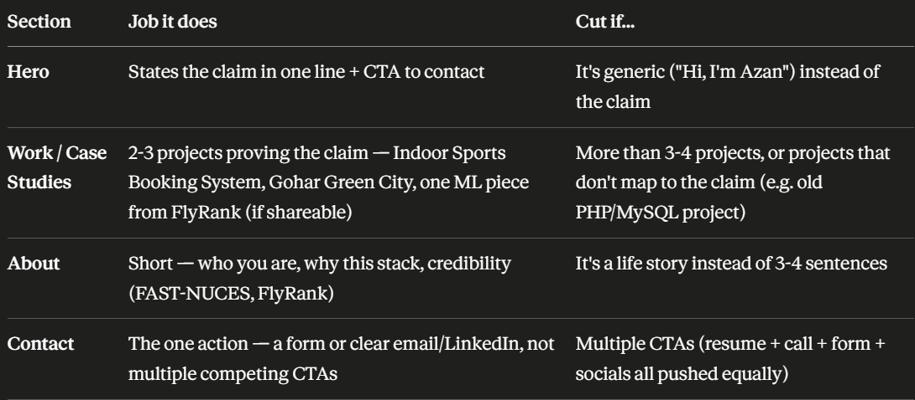

Pressure-Test Prompt:
I am creating a portfolio whose primary goal is to get contacted for software engineering and machine learning internship opportunities.
My proof statement is:
"I build reliable software and machine learning solutions by combining software engineering fundamentals with practical AI skills."
My sitemap is:
- Home (Hero)
- Featured Projects
- About Me
- Skills
- Contact
Please critique this sitemap.
Identify unnecessary pages, missing sections, weak areas, and suggest improvements that would increase recruiter confidence while keeping the site simple.
Claude’s Response:
Here's the critique, judged strictly against your claim and your one action (get contacted).
Proof statement check first "I build reliable software and machine learning solutions by combining software engineering fundamentals with practical AI skills" is safe but vague — it's a claim any bootcamp grad could paste in. Nothing in it is falsifiable or specific to you. A recruiter reading it learns nothing they couldn't learn from your job title. Compare to something like: "I ship full-stack systems end-to-end — from schema design to deployment — and apply that same rigor to ML workflows." That's checkable against your actual project work. Worth tightening before it goes in the hero.
Page-by-page
- Home (Hero) — Keep. But its only job is to state the claim + point to the one action. If it's currently a photo + name + generic tagline, that's a weak page pretending to be a strong one.
- Featured Projects — Keep, this is the page doing the actual proving. Weak spot: "Featured" implies curation, so it needs to actually be curated — 3 projects max, each explicitly mapped to either the SWE half or the ML half of your claim. If you have 6+ projects listed, that's not a portfolio, it's a résumé dump, and it dilutes rather than strengthens the claim.
- About Me — Keep, but keep it short. Its only job here is credibility (FAST-NUCES, FlyRank, why this stack) — not a life story. If it's doing more than 3-4 sentences of work, trim it.
- Skills — This is your weakest page. A skills list is the least convincing thing on a recruiter-facing site — everyone lists React, Python, SQL. It doesn't prove anything the Projects page doesn't already prove better. Two options: cut it entirely and fold key tech into project cards (tag each project with its stack), or keep it only as a compact strip near Projects, not a standalone section demanding its own scroll/click. I'd cut it.
- Contact — Keep, this is your one action. Weak spot to watch: make sure it's a single clear path (one form or one email/LinkedIn), not a wall of icons splitting attention across email, LinkedIn, GitHub, resume download, and a contact form all at once. Competing CTAs is the #1 way sites bleed the one action you're trying to drive.
Missing
Nothing structurally missing — five sections for this goal is already close to right-sized. The gap isn't a missing page, it's missing proof density inside Projects: for each project, a recruiter needs to see problem → your role → outcome/result in a few lines, not just a screenshot and tech-stack badges. That's what actually moves someone from "looks nice" to "I should message this guy."
Verdict: Cut or fold Skills. Tighten the proof statement before it hits the hero. Everything else earns its place — the leverage is in making Projects and Contact do their jobs harder, not adding sections.

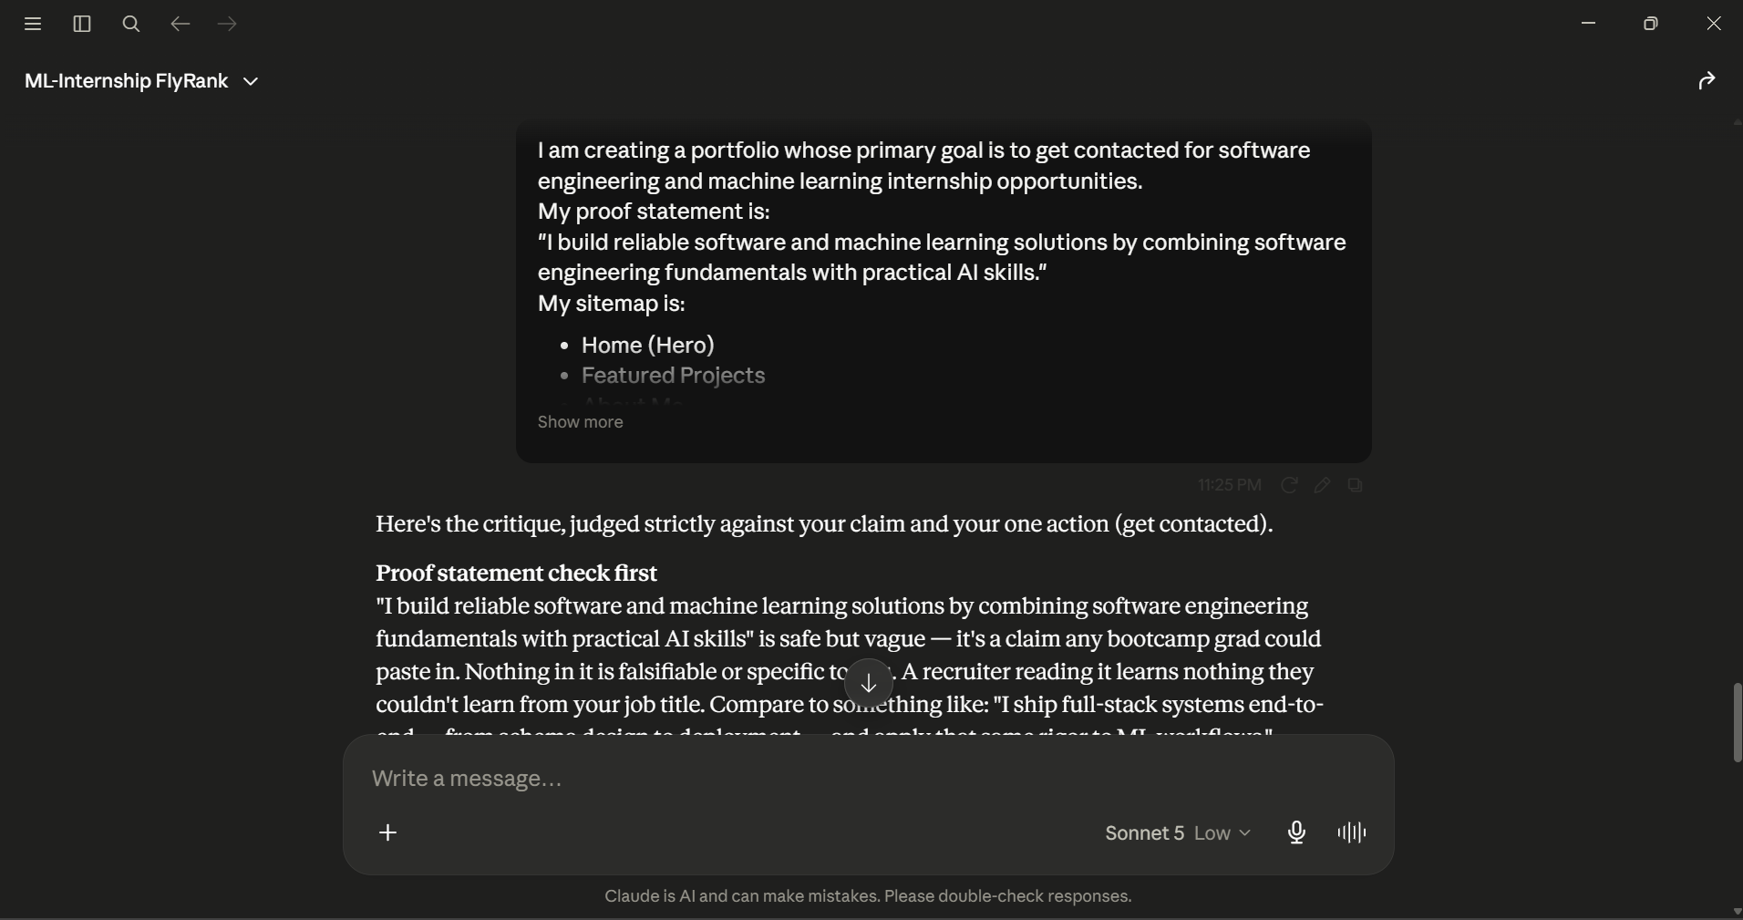
One Thing I will Change:
I will move my strongest projects higher on the homepage so visitors immediately see evidence supporting my claim before reading about me.

